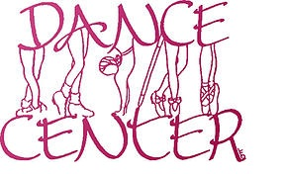

DANCE CENTER 2022-2023 CALENDAR

DATE TIME EVENT
Sept 12-16 |  | Classes begin 1st Payment DUE
Oct 24-28 |  | 2nd Payment DUE
Oct 24-28 |  | Bring a friend-Wear a costume to class
Oct 31 |  | Halloween
Nov 23-25 |  | Thanksgiving break – No classes
Dec 5-9 |  | 3rd Payment Due
Dec. | TBA | Christmas Dance Show
Dec 12-16 |  | Costume Deposits DUE
Dec 19-30 |  | Christmas Break – No classes
Jan 2 |  | Classes Resume
Jan 30- Feb 3 |  | 4th Payment DUE
Mar 13-17 |  | 5th Payment DUE
 | TBA | Spring Break – No classes
May 1-5 |  | 6th Payment DUE
May 29 |  | Memorial Day- No classes
June 5-9 | TBA | SPRING SHOW Location, dates, and times TBA

Dance Center 2022-2023 Payment Rate Schedule
For 6 Weeks Per Class
1 hour $66 $11
2 hours $84 $7
3 hours $114 $6.33
4 hours $180 $6
Family discount 10% off for second/or more student(s)

Adult Classes:
- Ballroom $25/couple/hour
- Tai chi $75/6 weeks
Check with specific teachers for payment arrangements or rate for private classes

