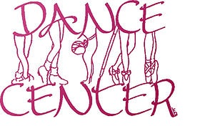

DANCE CENTER 2023-2024 CALENDAR

DATE TIME EVENT
Sept 11-15 |  | Classes begin 1st Payment Due
Oct 23-27 |  | 2nd Payment Due
Oct 30- Nov 3 |  | Bring a friend-Wear a costume to class
Oct 31 |  | Halloween
Nov 22-24 |  | Thanksgiving break – No classes
Dec 4-8 |  | 3rd Payment Due
Dec. | TBA | Retirement Home Christmas Dance Show
Dec 20- Jan 1 |  | Christmas Break – No classes
Jan 2 |  | Classes Resume
Jan 29- Feb 2 |  | 4th Payment Due
Mar 11-15 |  | 5th Payment Due/Costume Deposits Due
 | TBA | Spring Break – No classes
April 22 -26 |  | 6th Payment Due
May 27 |  | Memorial Day- No classes
June | TBA | SPRING SHOW Onsted School/Date and time TBA

Dance Center 2023-2024 Payment Rate Schedule
For 6 Weeks Per Class
1 hour $66 $11
2 hours $84 $7
3 hours $114 $6.33
4 hours $180 $6
Family discount 10% off for second/or more student(s)

Adult Classes:
- Ballroom $25/couple/hour
- Tai chi $10/class
Check with specific teachers for payment arrangements or rate for private classes

